

Best Practices

Administration

Credit Cards – Encryption/ Decryption

Security for credit card information is one our highest priorities these days. In answer to that challenge, The Concierge Assistant has taken numerous steps to assist everyone with that need.

The first step is the ability to encrypt each credit card number entered into The Concierge Assistant.

Logbook Credit Card Entries

When a vendor requires a credit card number for orders and or reservations, this information may be entered into The Concierge Assistant as a convenience for future orders or reservations or historical data for this guest.

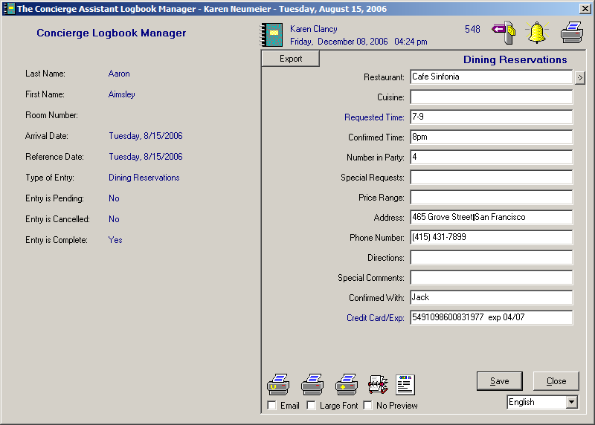

When the transaction is saved, by clicking on the Save button, the system will encrypt the credit card number and mask the first 11 or 12 numbers of the credit card by replacing them with x’s, showing only the last 4 numbers of the card. Also at that time, a small “CC” button will appear on both the front panel under the checkmark

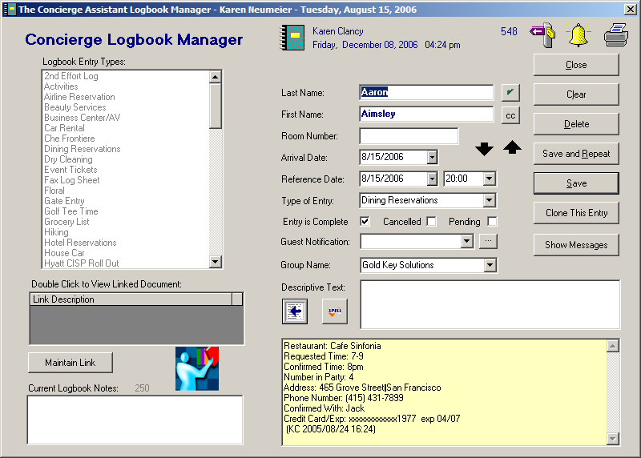

and the back panel under the Save button

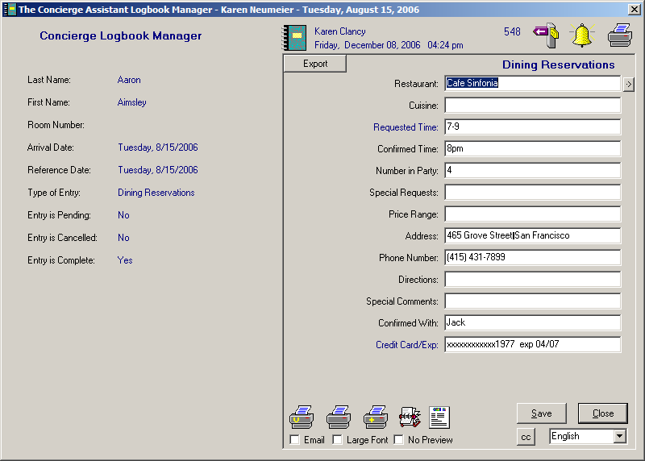
Decrypting the credit card requires a second password used only for this purpose. Simply start by clicking on either of the cc buttons. You will see this screen.

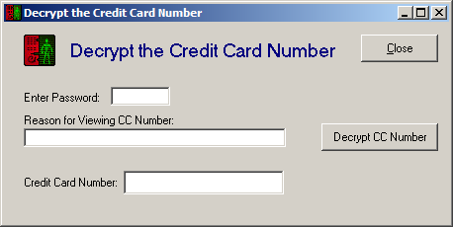

The very first time you are decrypting the credit card number, you will enter your logon name, exactly like the first time you entered into The Concierge Assistant, and the reason you are decrypting the credit card number. Click on the button “Decrypt CC Number”.

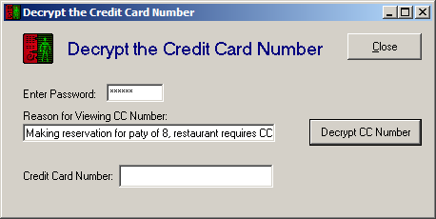

You will see this screen, prompting you for a new password. Enter the new password and then verify it in the second space provided. You may choose any password you desire as long as it is not the same as your logon password.

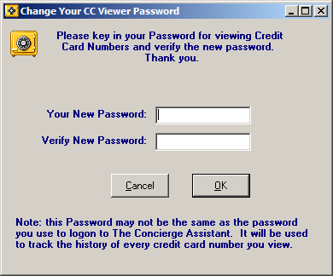

When you click on the OK button, your screen will return to the original decrypting screen. Now enter the new password you just created and click on the “Decrypt CC Number”. The system will present the encrypted number.

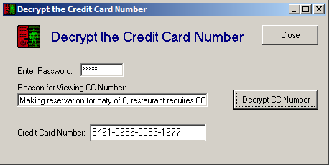

If the associate forgets his/her credit card password, you may reset it in Administration, Concierge Staff. After clicking on the associate’s name click the button labeled “Reset CC” or “Reset Passwords”, which will require both passwords to be re-established.

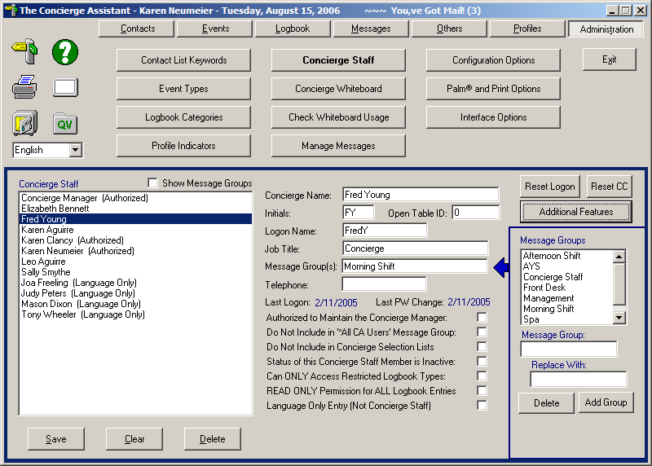

Profile Credit Card Entries

Credit Card information may also be stored in the “Profiles” feature of The Concierge Assistant for each guest for easy retrieval.
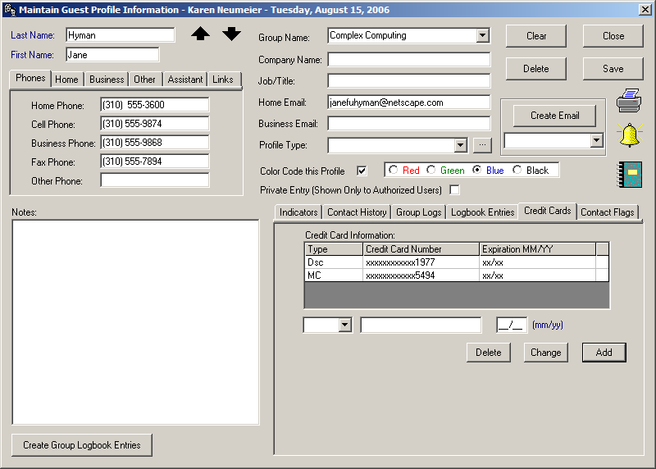

To decrypt a credit card in this area, double-click on the credit card number of your choice and you will get this screen.

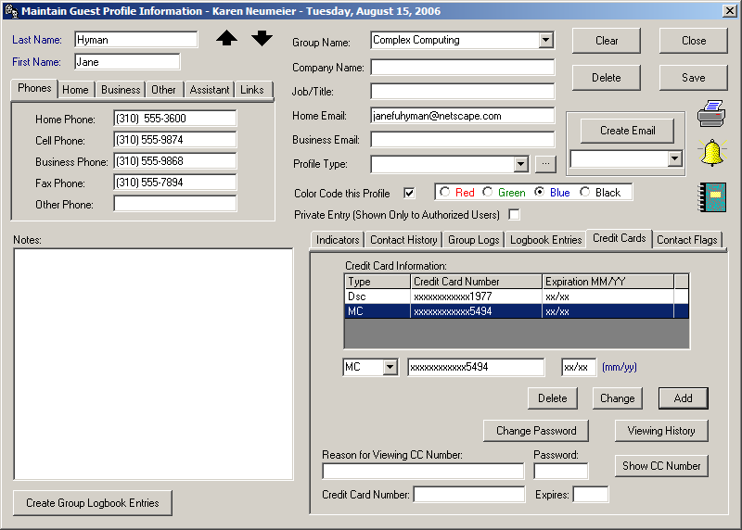
You must enter the reason for decrypting this credit card and your password. (If this is the first time at decrypting you will need to follow the steps described in the section for Logbook entries.)
Now click on the button labeled “Show CC Number”.

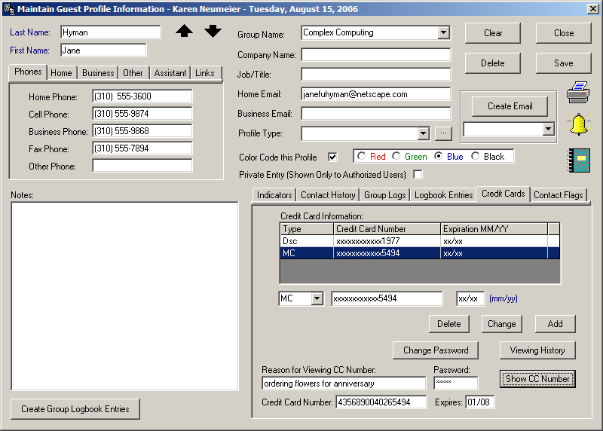
You have additional options in this screen that are not available through the logbook CC lookup, such as the ability to “Change Password” and a button for “Viewing History” of past CC lookups.

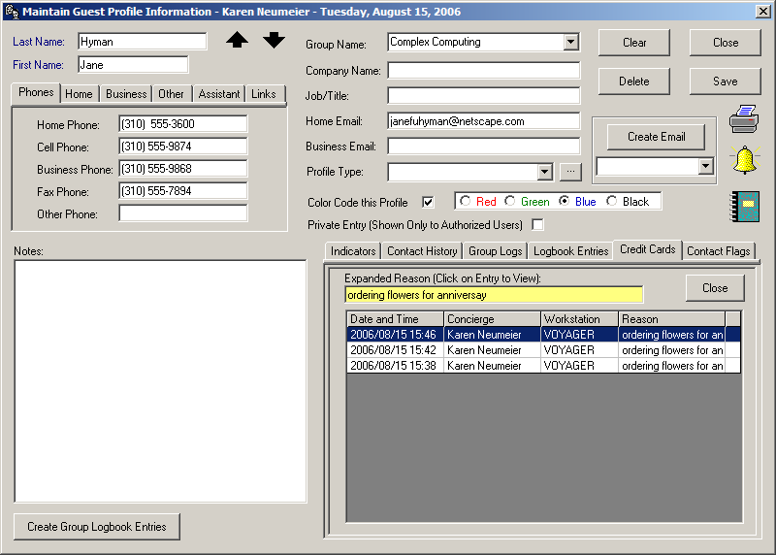

If the Logbook entry is generated from the Profile feature,

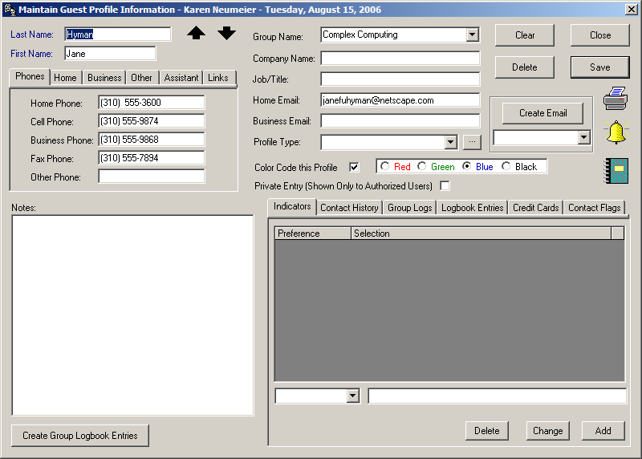

The Guest profile information comes over too.
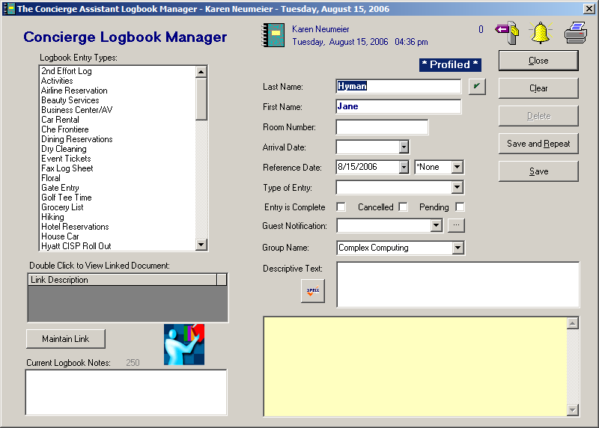

Click on the checkmark and you will get additional profile information, including credit cards.
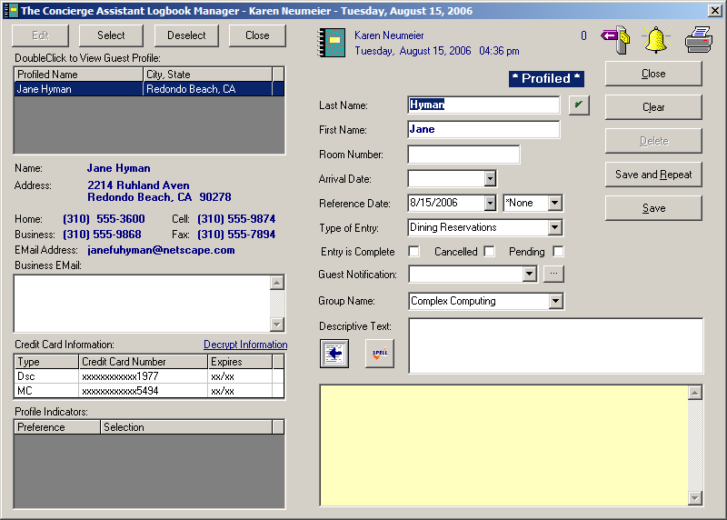

When you get to the data entry panel for this request, the credit card information is available
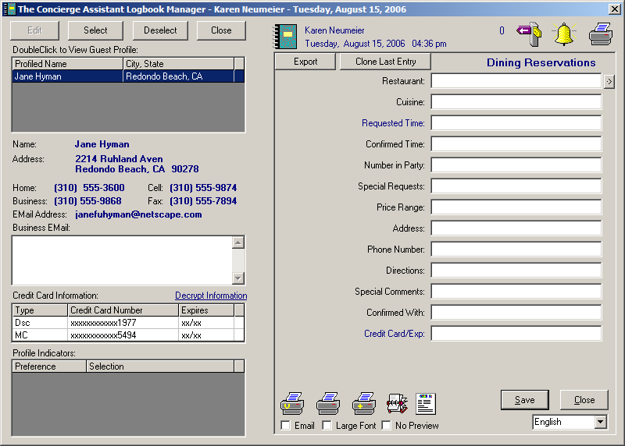

If you wish to decrypt the credit card information, simply click on the verbiage above the credit card field…”Decrypt Information”…
you will get this screen

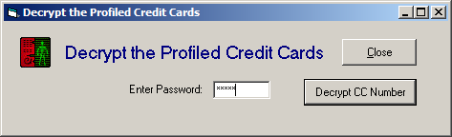

Enter your password and click on “Decrypt CC Number”

The screen will now reflect the decrypted credit card information.

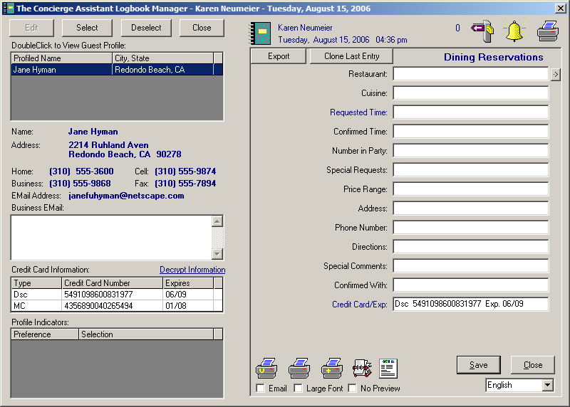

The credit card information is now available for orders and reservations just click and drag! When you save the logbook entry, the number will encrypt. Once the entry is Closed, the credit card info will re-encrypt for the Profiled guest, should this entry be reviewed in future.

Who’s Looking?

The second step of encrypting/decrypting credit cards is to know who is looking up credit card information and why.

In The Concierge Assistant, through the use of logon names and passwords, we have provided a means to create an “audit trail” of staff associates who are accessing this information via Logbook entries and the Profile feature.

This information is only accessible to “Authorized” individuals. In the Administration feature of The Concierge Assistant, click on the tab labeled “Configuration Options”, click on “Profile CC Entries” or “Logbook CC Entries”. You may also make selections on Successful and Unsuccessful attempts as well as Sort options for the final report. If a printed copy is needed, click the F4 function key for a screen shot.
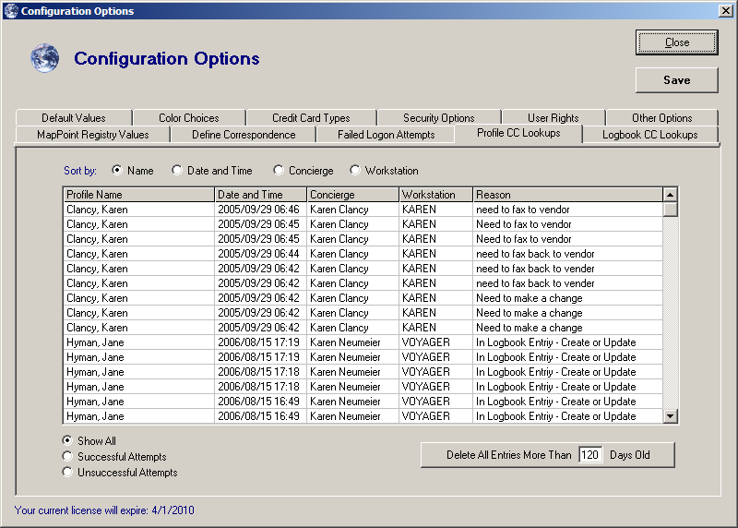

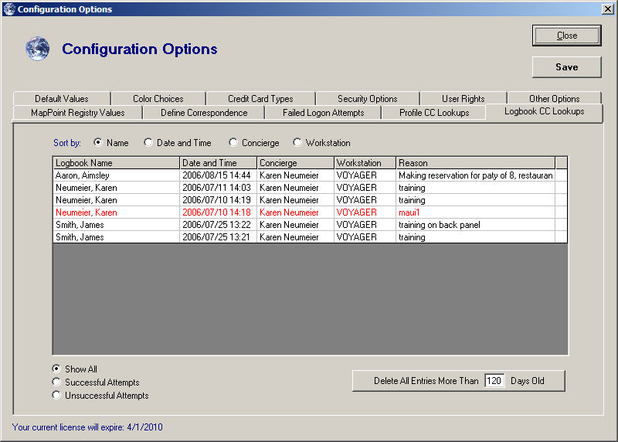
Who Is Authorized to Decrypt Credit Card Information?

All “Authorized” users are capable of decrypting Credit Card information. Authorized users are the Administrators and are given the responsibilities of the foundational controls in The Concierge Assistant. They have access to the “Administration” tab. The staff associates who are ”Authorized” need to have the box checked giving them that authority.
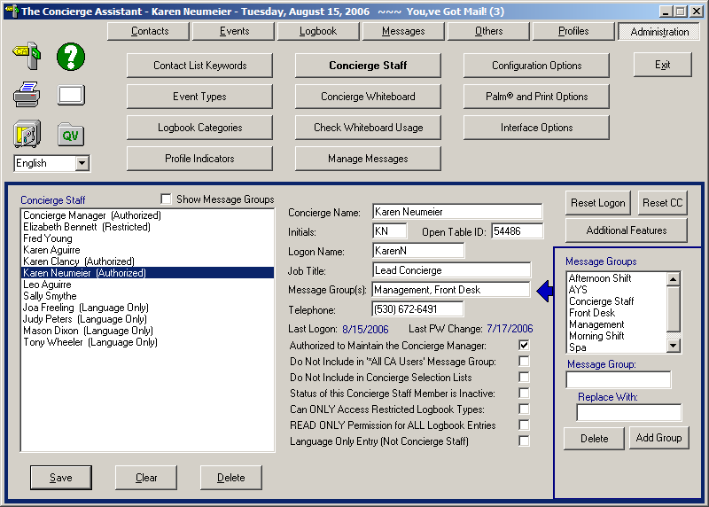
The permission to decrypt credit cards may be given to staff associates who are not considered “Authorized”.

Only “Authorized” individuals can give other staff associates the permission to decrypt credit card information. Under the “Administration” tab, click on “Concierge Staff” tab,
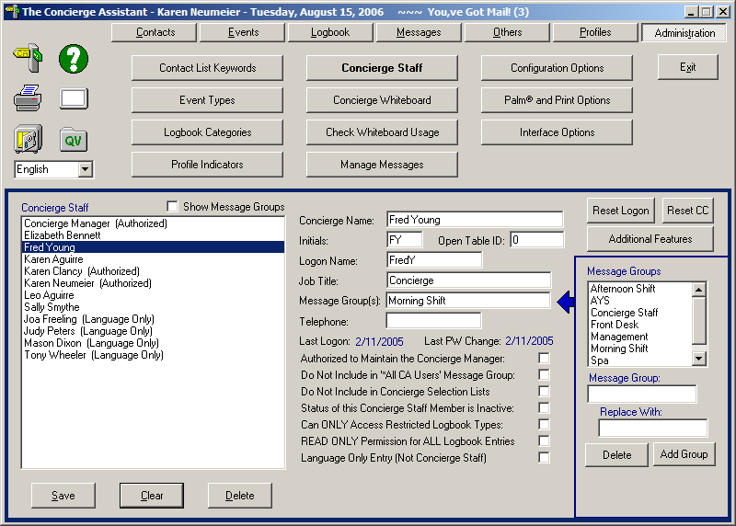
Click on the person you want to give permission to.
Now click on the button labeled “Additional Features”

Select “Security Authorizations” and the Logbook tab.
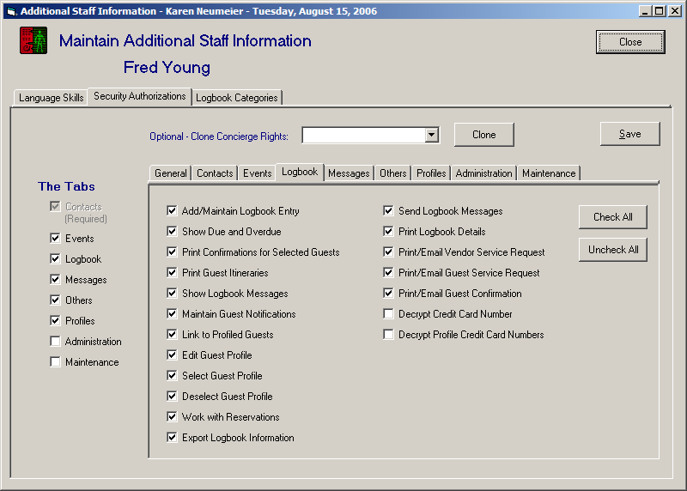

Check either or both boxes for decrypting ability and don’t forget to save.

